Session 1: Create A basic image

# SET UP BUILD ENVIRONMENTS

**PURPOSE: Understand what and how development environments needs to be set.**

Reference Links - [Tools](https://github.com/MicrosoftDocs/windows-iotcore-docs/blob/fabricam/windows-iotcore/manufacturing-guide/03-ToolsNeeded.md)

**WE INSTALLED ALREADY FOR YOU**

* You have a development PC, Logon ID = Administrator, Password = 1234
* You have IOT Device RPi3, Micro SD Card, LAN Connected to Hub, etc
* [Windows Assessment and Deployment Kit (Windows ADK)](https://docs.microsoft.com/windows-hardware/get-started/adk-install#winADK) installed. You can select minimum item in red box but suggest selecting all.

**[NOTE] - The version of ADK used must match the version of IoT Core Packages used below** [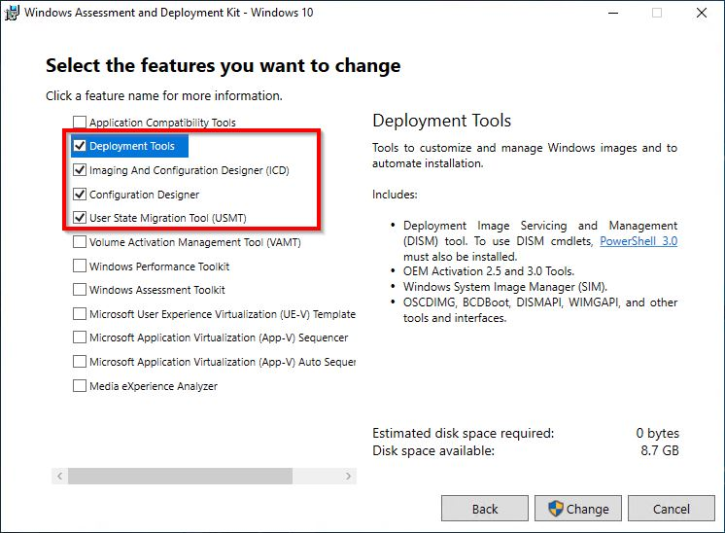](https://github.com/MicrosoftDocs/windows-iotcore-docs/blob/fabricam/windows-iotcore/media/ManufacturingGuide/WindowsADKSetup.jpg)

* [Windows PE add-on for the ADK](https://docs.microsoft.com/windows-hardware/get-started/adk-install#winADK) installed.
* [Windows Driver Kit (WDK) 10](https://docs.microsoft.com/windows-hardware/drivers/download-the-wdk) installed
* [Windows 10 IoT Core Packages](https://www.microsoft.com/en-us/software-download/windows10iotcore) , Windows 10 IoT Core, version 1809 ARM32 installed.
* [Windows 10 IoT Core Dashboard](http://go.microsoft.com/fwlink/p/?LinkId=708576)
* Visual Studio 2017 Community version, UWP enabled
* Install Windows **IoT Core Project Templates** for VS 2017 - [link](https://marketplace.visualstudio.com/items?itemName=MicrosoftIoT.WindowsIoTCoreProjectTemplatesforVS15)
* Optional, Visual Studio code - [Link](https://code.visualstudio.com/download)

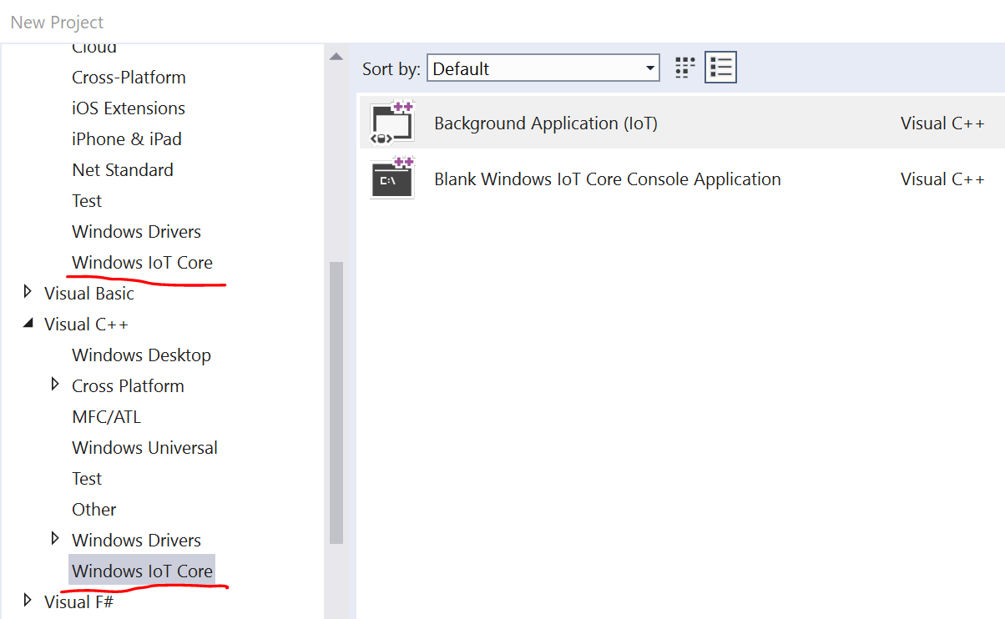

**PLEASE DO**

* Check **C:\Temp\2019-IOT-HOL** folder
  + **iot-adk-addonkit-master.zip** downloaded, [IoT Core ADK Add-Ons](https://github.com/ms-iot/iot-adk-addonkit/)
  + Raspberry Pi BSP **RPi_BSP.zip** downloaded from [RPi BSP](https://github.com/ms-iot/iot-adk-addonkit/releases/download/17134_v5.3/RPi_BSP.zip).
  + **Programs** folder exist
  + **FY2019Q3 IoT Core HOL Training Docs**
  + FY2019 Q2 IoT Core Training Decks for reference.
* Unzip **iot-adk-addonkt-master.zip** and move and rename the directory to **C:\iot-adk-addonkit**

# Create basic image

**PURPOSE: Understand IoT Core image build environment and Build Basic Image**

Reference – [IoT Core Image Creation Process](https://docs.microsoft.com/en-us/windows-hardware/manufacture/iot/iot-core-manufacturing-guide), [Create Basic Image](https://github.com/MicrosoftDocs/windows-iotcore-docs/blob/fabricam/windows-iotcore/manufacturing-guide/04-CreateBasicImage.md)

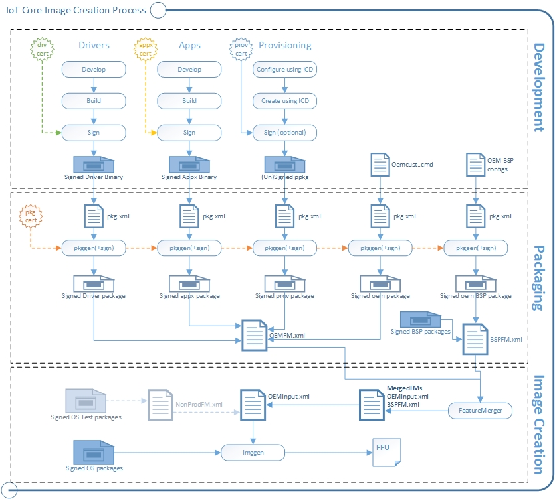

* Install necessary certificates. Run cmd as administrator and run installoemcerts.cmd

*Ex) set WPDKCONTENTROOT=C:\Program Files (x86)\Windows Kits\10*

*Ex) C:\Program Files (x86)\Windows Kits\10\tools\bin\i386>installoemcerts.cmd*

**[Tip]** If you use ‘ “ ’ for path name then you might see error to run installoemcerts.cmd

* In Windows Explorer, go to **C:\iot-adk-addonkit** and open **IoTCorePShell.cmd**. It should prompt you to run as an administrator

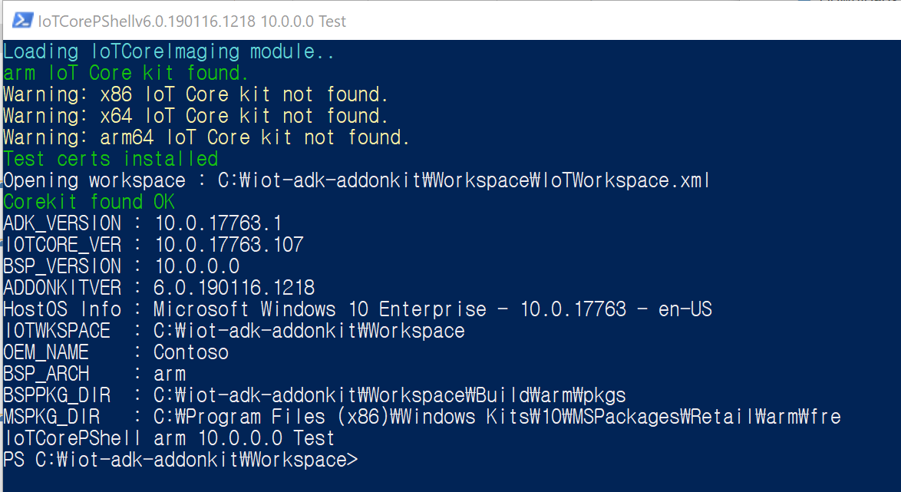

* In the IoT Core Powershell Environment, create a new workspace (for example, C:\Myworkspace) with your **OEM name** like **Contoso** with **arm** option for the architecture [New-IoTWorkspace](https://github.com/ms-iot/iot-adk-addonkit/blob/master/Tools/IoTCoreImaging/Docs/New-IoTWorkspace.md) as we will use RPi3 ARM based board.

*Ex) PS C:\iot-adk-addonkit\Workspace>New-IoTWorkspace c:\MyWorkspace Contoso arm*

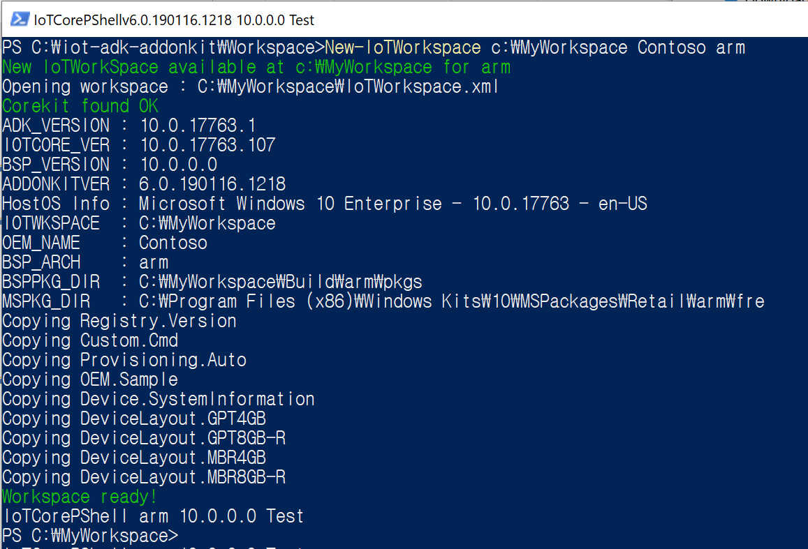

* Import the BSP using [Import-IoTBSP](https://github.com/ms-iot/iot-adk-addonkit/blob/master/Tools/IoTCoreImaging/Docs/Import-IoTBSP.md)

*PS C:\MyWorkspace>Import-IoTBSP RPi2 C:\Temp\2019-IOT-HOL\RPi_BSP.zip*

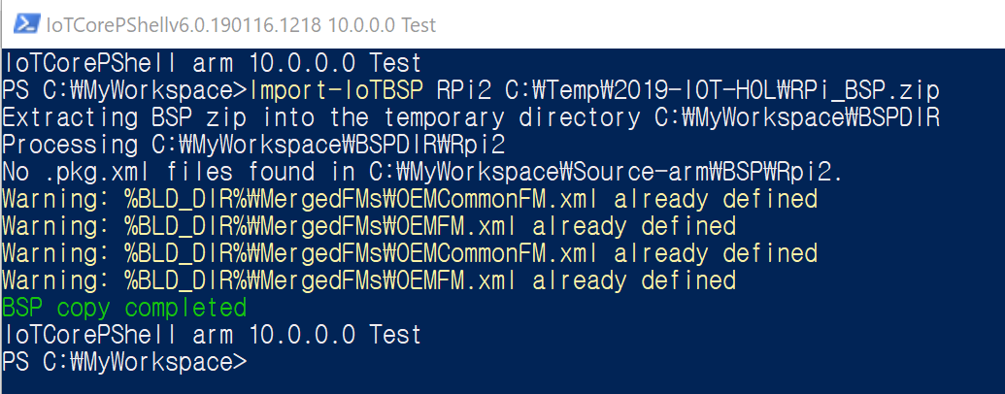**[Note**] Qualcomm, **Intel** and **RPi** have different ways to import BSP more details are in [here](https://github.com/MicrosoftDocs/windows-iotcore-docs/blob/fabricam/windows-iotcore/manufacturing-guide/Concepts-Terms-Basics/BoardSupportPackages.md).

* Get your environment ready to create products by building all of the packages in the working folders (using [New-IoTCabPackage](https://github.com/ms-iot/iot-adk-addonkit/blob/master/Tools/IoTCoreImaging/Docs/New-IoTCabPackage.md))

*Ex) PS C:\MyWorkspace>New-IoTCabPackage All*

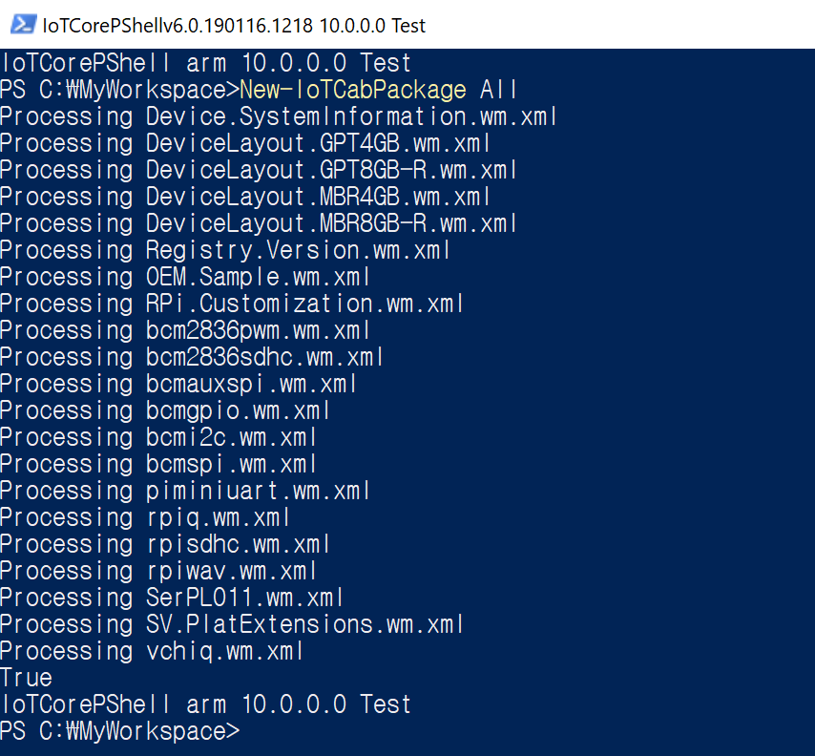

* Create a new **product** folder that uses the BSP you are working with. This folder **represents a new device** we want to build an image for and contains sample customization files that we can use to start our project. Execute the following command using [Add-IoTProduct](https://github.com/ms-iot/iot-adk-addonkit/blob/master/Tools/IoTCoreImaging/Docs/Add-IoTProduct.md).

**[Note]**You will be prompted to enter the **SMBIOS** information, such as Manufacturer Name (OEM Name), Family, SKU, BaseboardManufacturer, and BaseboardProduct. This is used when you make your device connected to **IoT Core Service**. Here are some example values:

* + - System OEM Name: Contoso
    - System Family Name: Sample Family
    - System SKU Number: P001
    - Baseboard Manufacturer: RaspberryPi
    - **Baseboard Product: RPi2**

The **BSP name is the same as the folder name for the BSP**. You can see which BSPs are available by looking in the [Your Workspace] \Source-<arch>\BSP folders

*Ex) PS C:\MyWorkspace>Add-IoTProduct ProductA RPi2*

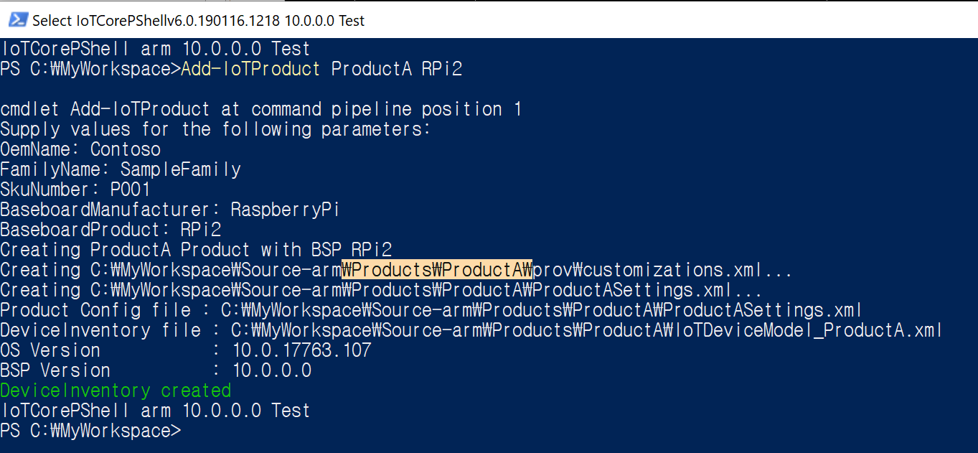

* Every image includes a file oemcustomization.cmd which will run on every boot up of your device. You have the ability to modify this file to customize what executes on boot up. This file is located under [Your Workspace]/Source-<arch>/Products/<your product name>. Here is an example of what this file holds: Add Administrator account and password

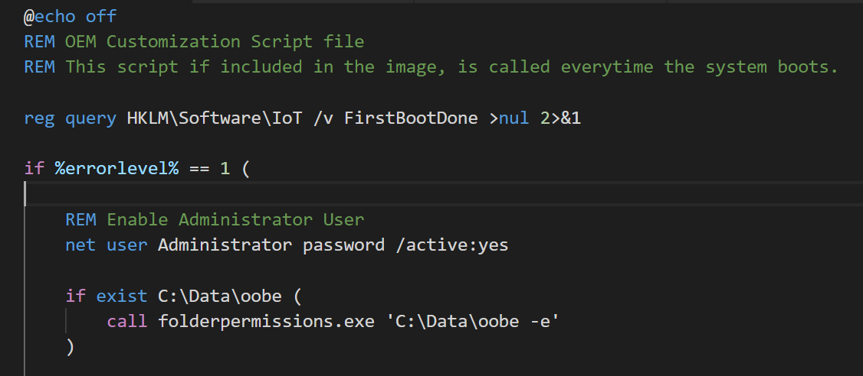

**[Note]** Please be aware that the commands in this file run with local system privilege.

**[Tip]** “ > /dev/null” redirects the stdout , “2>&1” redirects the stderr to the stdout. %errorlevel% keeps the execution result success(0) or fail(1) of the command lately run.

* Build the FFU image file by entering the following command in IoT Core Powershell Environment using [New-IoTFFUImage](https://github.com/ms-iot/iot-adk-addonkit/blob/master/Tools/IoTCoreImaging/Docs/New-IoTFFUImage.md)

*Ex) PS C:\MyWorkspace>New-IoTFFUImage ProductA Test*

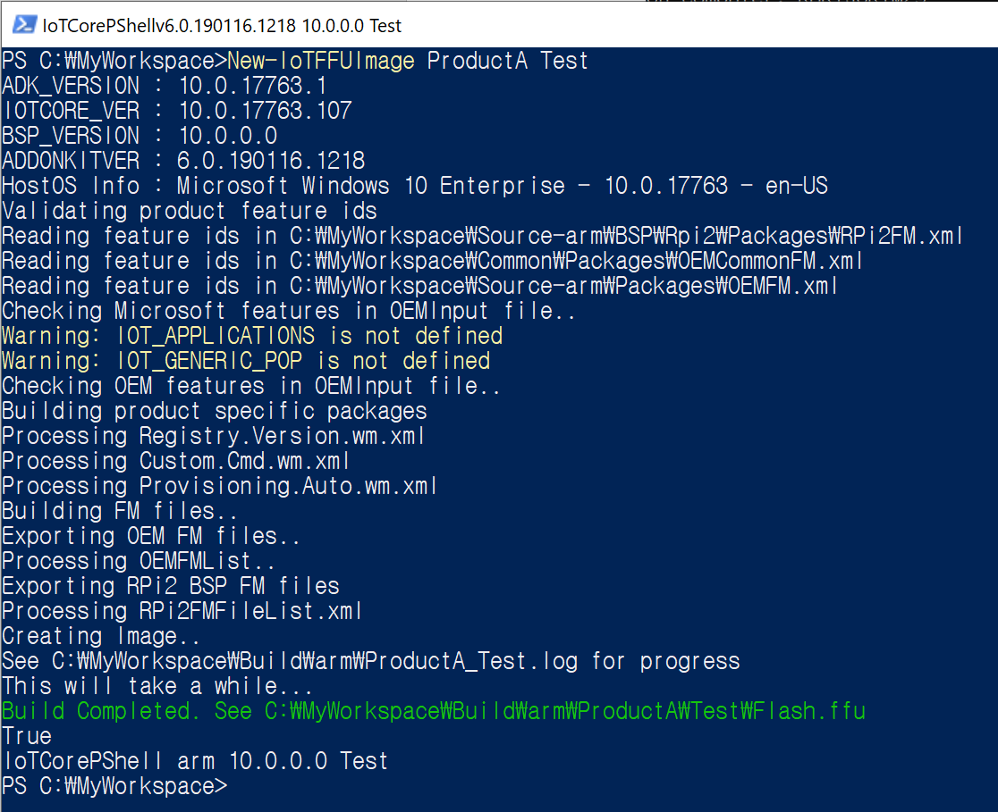

**[Note!!]** **Eject any removable storage drives**, including the microSD card and any USB flash drives. And, the second parameter specifies whether you are building a Test or Retail image

**[Tip]** If you want to switch Workspace in IoTCoreShell thenreopen the workspace

*Ex) PS C:\iot-adk-addonkit\Workspace>Open-IoTWorkspace C:\MyWorkspace\IoTWorkspace.xml*

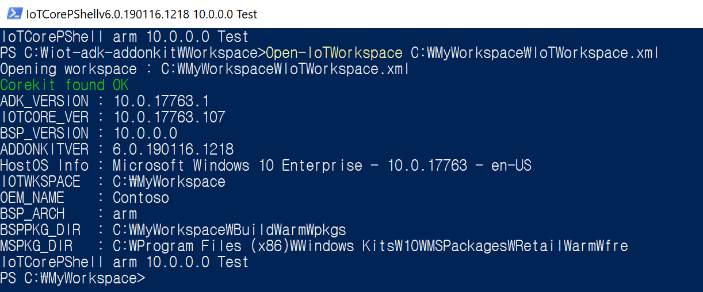

# QUIz

**Q1: Change your device’s name with oemcustomization.cmd**